The main parameter I am designing around with the parachute is descent speed. Parachutes reach terminal velocity where the drag force from the parachute is equal to the dry weight of the rocket after burnout. We can use the drag force equation:

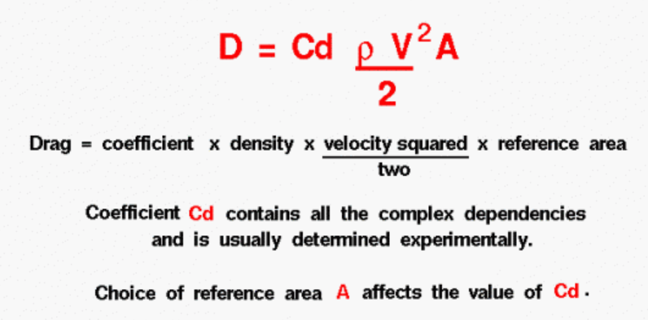

Coefficient of Drag for model rocket parachutes is estimated at 0.75 as per:

<https://apogeerockets.com/education/downloads/Newsletter149.pdf>

<https://www.grc.nasa.gov/www/k-12/VirtualAero/BottleRocket/airplane/rktvrecv>

The density of air at sea level ~1.225 kg/m^3.

Typical safe landing velocities are generally less than 6m/s. Apogee recommends 3.5-4.5 m/s.

* The decision for landing speed ultimately comes down to being soft enough to safely touch down without damaging any flight hardware while being small enough so that it doesn’t introduce any significant amount of mass.

The required drag force is equal to the force of gravity of the rocket, which we can calculate from the mass of the rocket. From there, the area of the parachute can be calculated.

It’s important to note that the area of the parachute should be the projected area not the surface area. However, these areas often do not vary by much and can be assumed to be the same.